Z Customization Process

PMS170/B (Sorting 3 / View 51)  
Enter CO number in the ‘Ref order no’ field  
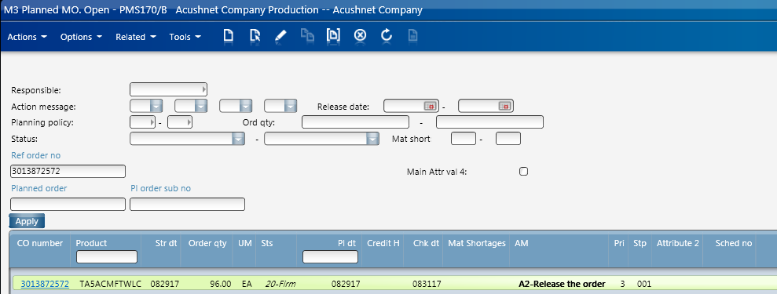

Highlight order line  
Select ‘change’  
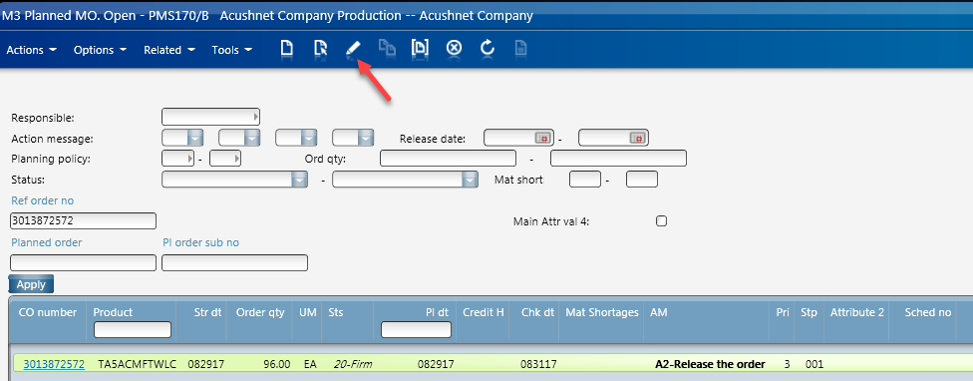  
Adjust order ‘structure type’ from 001 to 003 (MO Sub Contract)  
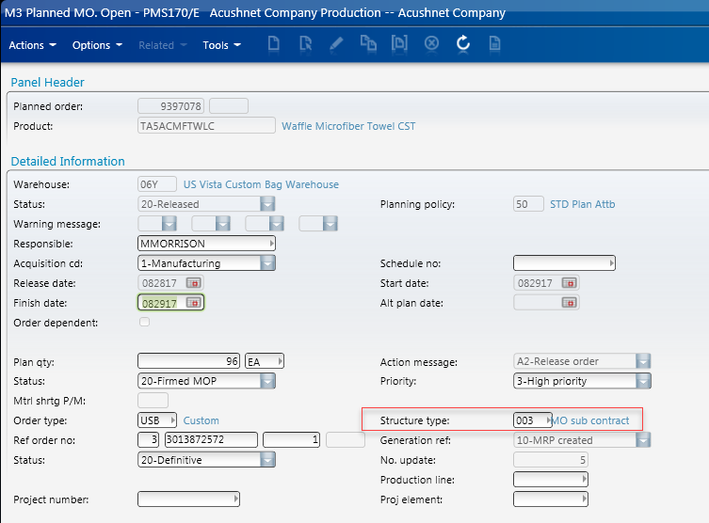  
By doing so, at the release of the Planned MO, the Supply Chain will build an RO to remove the materials from 06Y and deliver to Z Customization. This chain of events will also initiate and PO for the Sub Contractor   
Add Z Customization schedule number to Planned order  
(ZC schedule numbers always begin with ‘300’ followed by the release date of the order line)  
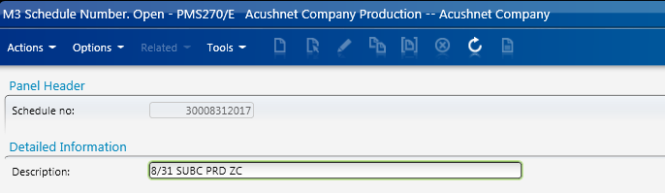  
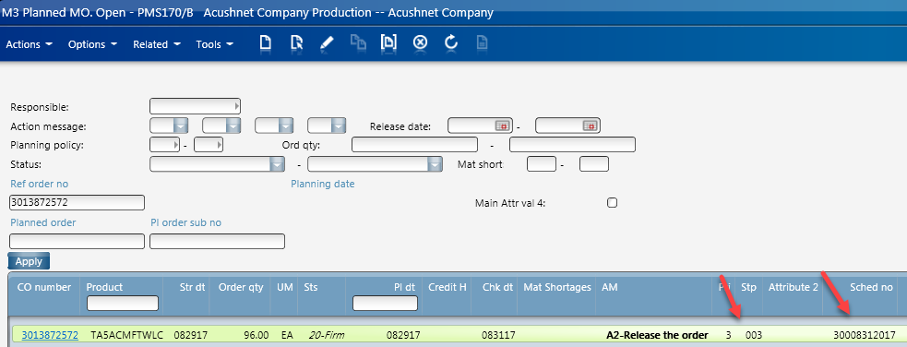  
Release the order  
Open MWS150 (Supply Chain)  
Enter CO number into Order Line field 1, enter (1) in field 2, leave field 3 blank  
\*allow M3 a few minutes to release the planned MO and build the Supply Chain  
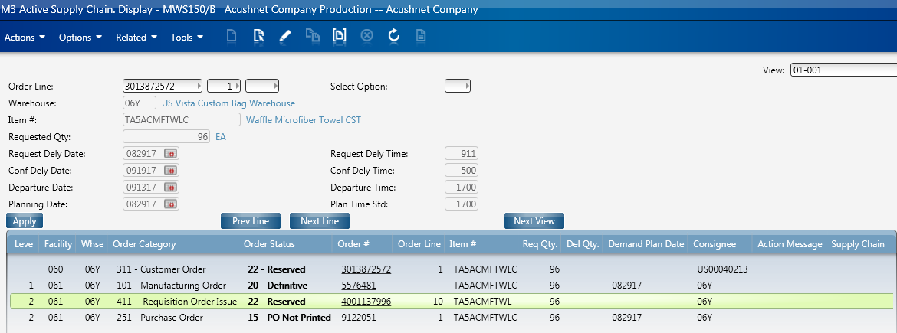  
In this particular example the RO line is not in the correct status due to a lack of inventory. Normally you would see the RO updated to status 33-Allocated;

\*\*After the script runs go in to MMS100, enter facility, order type USO, Low/High status to 44, your RO should be the only one available, highlight it, open side panel and click delivery toolbox. Find the RO delivery number, process through “Vista Custom Bag” location in KPack, notice the RO delivery updates to 30-packed. Click picking lists, status is 60, click confirm issues, status updates to 90. Return to supply chain status updates to 99. \*\*

\*\*If status doesn’t update to 99, in RO delivery toolbox click “Pick Reporting” link and observe shipping status updates to 90, RO in supply chain updates to 99\*\*

\*\*After RO status updates to 99 in supply chain, PO needs to be processed through KPack and Flagship\*\*

From here, communication will go out to Dave Granillo and team, referencing the RO number that needs to be released for picking. Once the materials are picked for this order – they are delivered to the shipping department. RO status will update to status ‘55’. Once delivered to Z Customization, RO status will update to ‘66’ delivered, and then ‘90’ or ‘99’ complete.

Z Customization will then manufacture the goods. The PO in the Supply Chain will get a status up to 20-Printed. Once ZC is ready to ship the product, they will enter the PO number in Kpack (ZC has their own Kpack log in). Kpack will be completed against the PO number – Carton contents labels will be applied to the finished goods cartons.

Z Customization will not complete the order in Flagship (ZC has their own Log in for the program as well). The package numbers will be scanned into Flagship – ‘shipped’. New shipping label will be printed and applied to the finished good cartons. Order is complete.